**NIT3222 – Virtualisation in Computing**

**Lab 1**

***ID: s4650134 Name: __Fang Sen________ __________***

1. VMware setup
   1. Login into VMware

Log into VMware vSphere using the address:

ictlabs.vu.edu.au

Consult the lecturer for username and password.

* 1. Change password

It is advised that you change your password for vSphere.

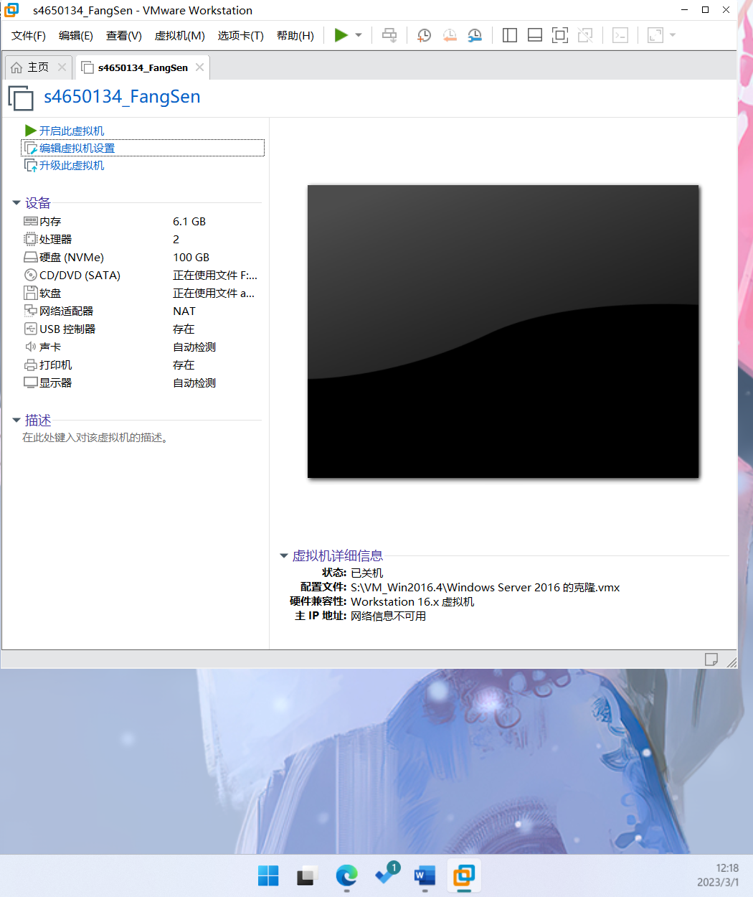

Figure 1.1

1. Install Hyper-V and other features
   1. Install the following features

* .NET framework 3.5
  + Mount the installation DVD that starts with ‘9600.17050.WINBLUE_REFRESH’.
  + On the confirmation page of the ‘Add Roles and Features Wizard’ click ‘Specify an alternate source path’.
  + Add ‘D:\sources\sxs’ to the Path field, where D: is the mounted DVD.
* Telnet client
* 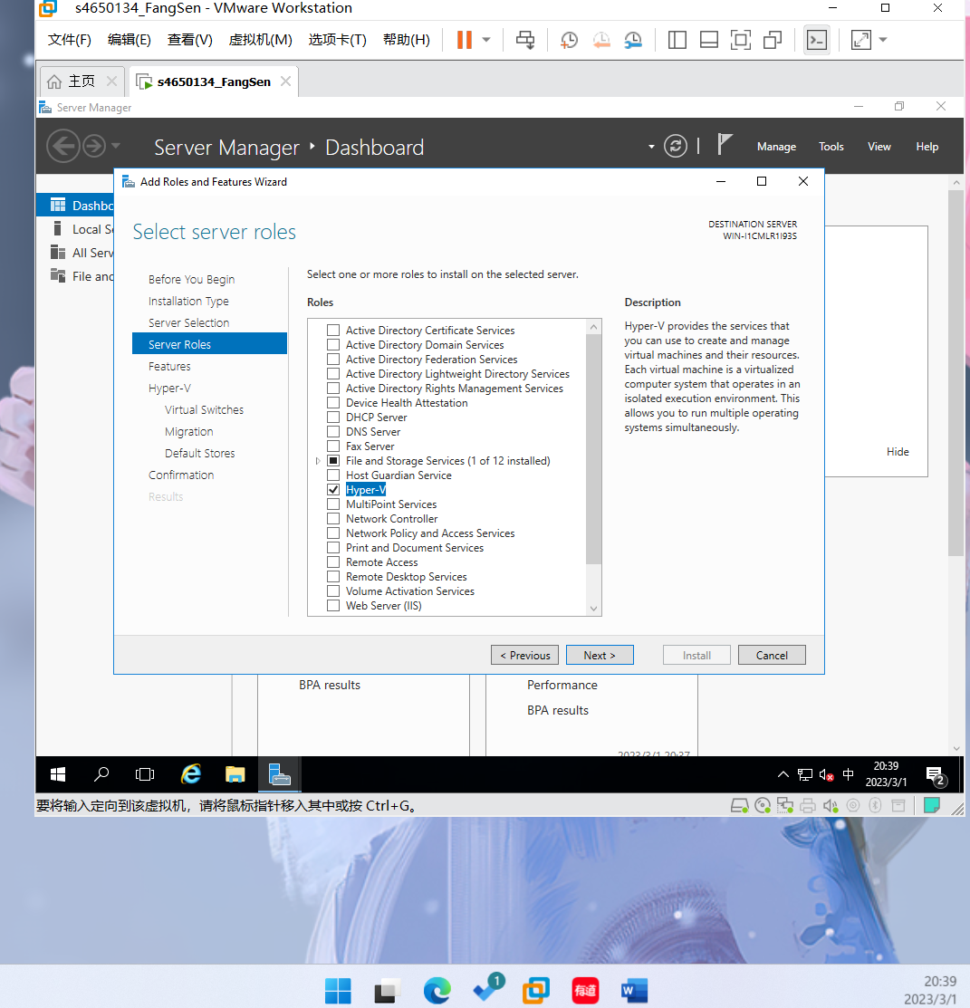

Figure 2.1

* 1. Install the following roles
* Hyper-V

Upon completion, demonstrate to the lecturer your setup.

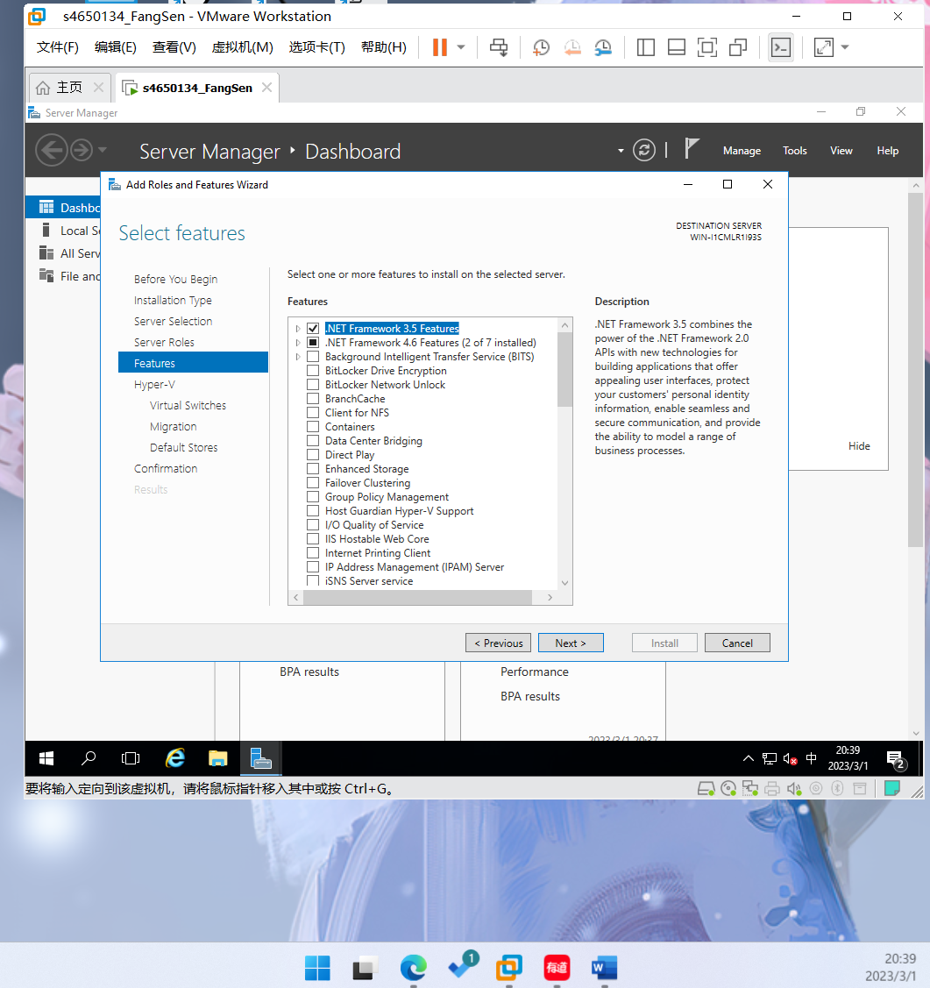

Figure 2.2